Technical sergeant Josuel G. German
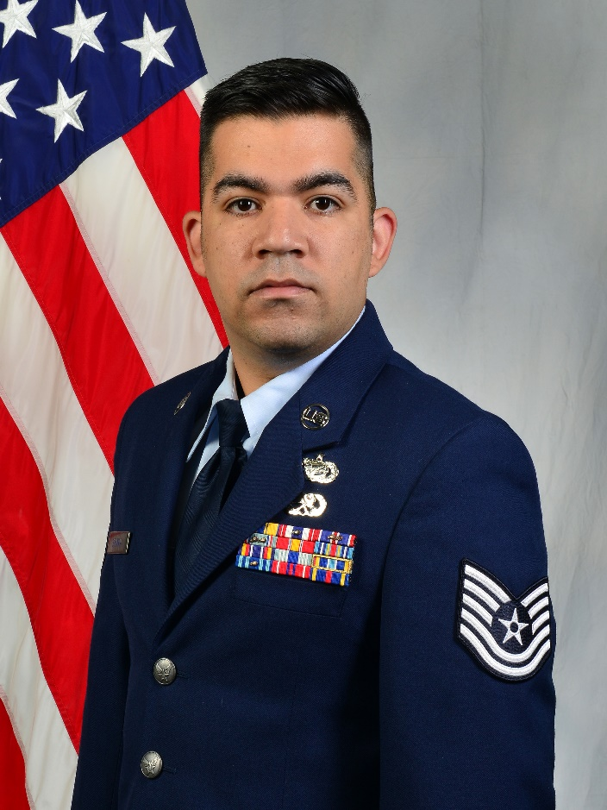
Technical Sergeant German is the Non-Commissioned Officer in Charge, Administration at the Air Force Reserve Officer Training Corps, Detachment 800 at The University of Tennessee, Knoxville TN. He manages the cadet uniform program, tracking $310K worth of uniform items. He also manages the cadet medical program, ensuring all ascension requirements are met before commissioning.

Sergeant German entered active duty in 2010 after completing Basic Military Training at Lackland Air Force Base, San Antonio TX. He served as an Aerospace Ground Equipment Journeyman prior to cross training to Administration. He also worked as the NCOIC at the wing, group and squadron level as well as postmaster prior to his current position.

EDUCATION:
2015 Airman Leadership School, Ellsworth AFB, South Dakota
2019 Associates Degree in Information Resource Management, Community College of the Air Force

2019 Associates Degree in Aerospace Ground Equipment Maintenance, Community College of the Air Force

ASSIGNMENTS:
1. May 2010 – November 2010, Student, 361st Training Squadron, Sheppard AFB, TX
2. November 2010 – January 2013, Aerospace Ground Equipment Apprentice, 48th Maintenance Squadron, RAF Lakenheath, UK
3. January 2013 – August 2016, Aerospace Ground Equipment Journeyman, 28th Maintenance Squadron, Ellsworth AFB, SD
4. August 2016 – April 2017, NCOIC, Wing Executive Admin, 432nd Wing, Creech AFB, NV
5. April 2017 – December 2018, NCOIC, Group Executive Admin, 732nd Operations Group, Creech AFB, NV
6. December 2018 – November 2019, NCOIC, Commander Support Staff, 732nd Operations Support Squadron, Creech AFB, NV
7. November 2019 – August 2020, Postmaster, 432nd Mission Support Squadron, Creech AFB, NV
8. August 2020 – Present, NCOIC, Administration, Detachment 800, University of Tennessee, Knoxville TN

MAJOR AWARDS AND DECORATIONS:
Air Force Commendation Medal
Air Force Achievement Medal
Meritorious Unit Award with one oak leaf cluster
Air Force Outstanding Unit Award with two oak leaf clusters
Air Force Good Conduct Medal with two oak leaf clusters
National Defense Service Medal
Global War on Terrorism Expeditionary Medal
Global War on Terrorism Service Medal
Air Force Overseas Long Tour Ribbon
Air Force Expeditionary Service Ribbon with Gold Border
Air Force Longevity Service Ribbon with one oak leaf clusters
USAF NCO PME Graduate Ribbon
Air Force Training Ribbon

EFFECTIVE DATES OF PROMOTION:
Airman Basic March 16, 2010
Airman First Class May 14, 2010
Senior Airman September 14, 2012
Staff Sergeant November 1, 2015
Technical Sergeant October 1, 2021

(Current as of February 2022)

