MAJOR RONALD L. WINDHAM JR.
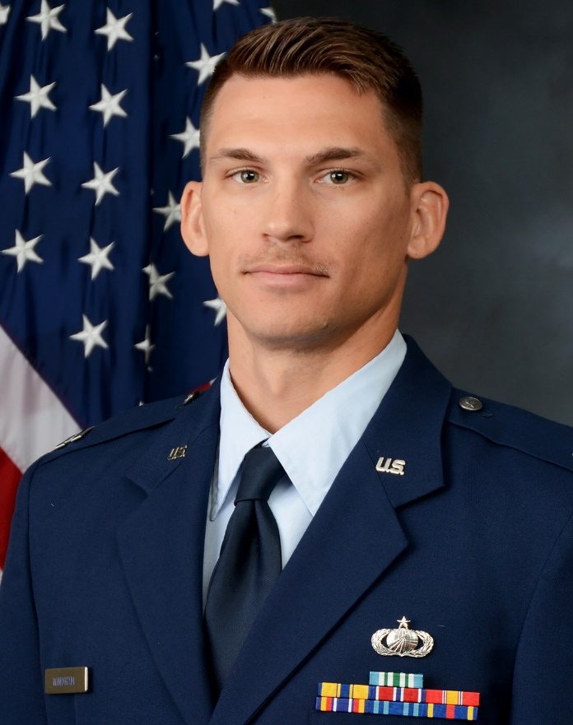
Major Ron Windham is the Associate Professor of Aerospace Science, Air Force Reserve Officer Training Corps (AFROTC), Detachment 800, The University of Tennessee, Knoxville. As Associate Professor of Aerospace Science, he leads the training and education program for 100+ cadets in pursuit of becoming commissioned Air Force and Space Force officers.

Maj Windham was commissioned in 2012 as a graduate of the Air Force Academy. In his previous acquisition assignments, Maj Windham served in numerous program management and leadership positions. Prior to his current assignment, he served as the Deputy Branch Chief for AIM-260A Joint Advance Tactical Missile (JATM) Hardware and Production responsible for more than 1k personnel executing an ACAT ID equivalent $35B+ contract leading all system design, qualification and fielding for the Air Force and Navy’s #1 Air-to-Air weapon.

During his career, Maj Windham has deployed with the Air Force and SOCOM to multiple locations in support of OPERATION INHERIT RESOLVE.

EDUCATION
2012 Bachelor’s degree, Science, System Engineering Management, United States Air Force Academy, Colo
2015 Master’s degree, Business Administration, Amberton University, Tex
2017 Squadron Officer School, Maxwell Air Force Base, Ala
2022 Air Command and Staff College, Maxwell Air Force Base, Ala

ASSIGNMENTS
1. July 2012 – August 2013, Deputy Program Manager, Operations Support System Division, Business and Enterprise Systems Directorate, Maxwell-Gunter Air Force Base, Ala
2. September 2013 – September 2015 Deliberate and Crisis Action Planning and Execution System (DCAPES) Program Manager, Business and Enterprise Systems Directorate, Maxwell-Gunter Air Force Base, Ala
3. August 2015 – March 2016 Division Executive Officer, Business and Enterprise Systems Directorate, Maxwell-Gunter Air Force Base, Ala
4. April 2016 – February 2018 Program Manager Advanced Tactical Communication, Command, Control, Communication, Intelligence, and Networks (C3I&N) Directorate, Hanscom Air Force Base, Mass
7. March 2018 – September 2020 Lead Program Manager Advanced Tactical Communication Portfolio, Command, Control, Communication, Intelligence, and Networks Directorate, Hanscom Air Force Base, Mass
8. October 2020 – November 2021 AIM-260A Aircraft Integration Section Lead, Armament Directorate, Eglin Air Force Base, Fla
9. December 2021 – July 2022, Section Lead, AIM-260A Aircraft Integration & Test Program Manager, Armament Directorate, Eglin Air Force Base, Fla
10. August 2022 – May 2024, Deputy Branch Chief, AIM-260A JATM Hardware Production and Design, Armament Directorate, Eglin Air Force Base, Fla
11. June 2024 – Present, Associate Professor of Aerospace Science, University of Tennessee, Knoxville, TN

MAJOR AWARDS AND DECORATIONS
Air Force Defense Meritorious Service Medal
Joint Service Commendation Medal
Air Force Commendation Medal with oak leaf cluster

EFFECTIVE DATES OF PROMOTION
Second Lieutenant May 23, 2012
First Lieutenant May 23, 2014
Captain May 23, 2016
Major Nov 1, 2021

(CURRENT AS OF JUNE 2024)

