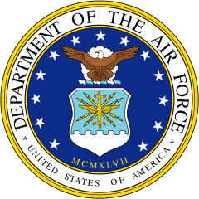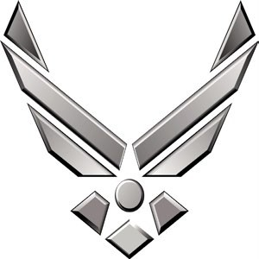BIOGRAPHY

*U N I T ED ST AT ES AI R F O RCE*

**major robert “rebel” willix**

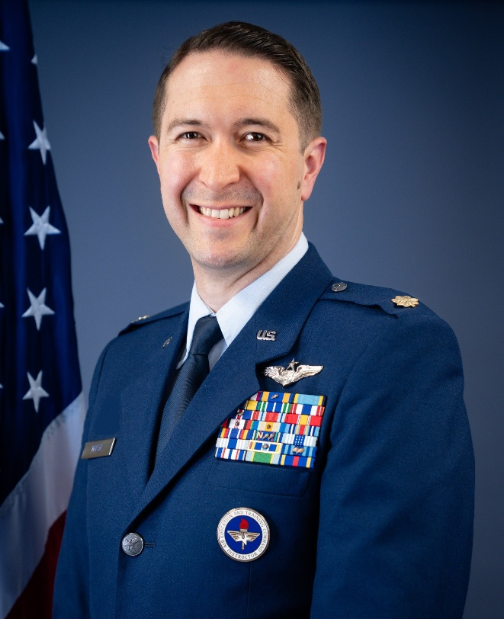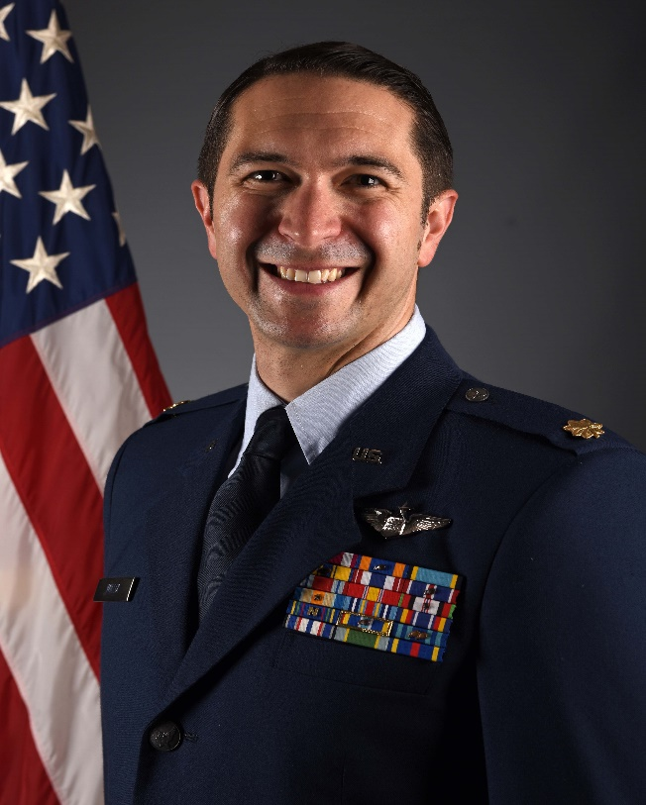  
Major Robert C. Willix is the Associate Professor of Aerospace Science, Air Force Reserve Officer Training Corps (AFROTC), Detachment 800, The University of Tennessee, Knoxville. As Associate Professor of Aerospace Science, he leads the training and education program for 100+ cadets in pursuit of becoming commissioned Air Force and Space Force officers.

Maj Willix entered the Air Force through Officer Training School in August 2012. He graduated from Undergraduate Combat Systems Officer Training in 2013 and B52H Electronic Warfare Officer Initial Qualification in 2014. He has had a diverse career path with extensive nuclear operations and policy experience. He served as a Flight Instructor in two Major Weapon Systems. Prior to his current position, Maj Willix was the Commander for the 39 Operations Support Squadron at Incirlik Air Base, Turkiye.

Maj Willix is a Senior Combat Systems Officer with over 1600 hours and has served as an AETC Master Instructor in the B-52H and T-1A. He has operational experience in Operations INHERENT RESOLVE and FREEDOMS SENTINEL with nearly 500 combat hours.

# EDUCATION

|  |  |
| --- | --- |
| 2012 | Bachelor of Science in Molecular Biology, Western Carolina University, Cullowhee, NC |
| 2016 | Master of Business Administration, Liberty University, Lynchburg, VA |
| 2019 | Squadron Officer School, Maxwell AFB, AL |
| 2020 | Nuclear Weapons, Effects, Policy, and Proliferation Certification, AFIT, Wright-Patterson AFB, OH |
| 2020 | Master of Science, Defense and Strategic Studies, Missouri State University, Springfield, MO |
| 2022 | Air Command and Staff College, Maxwell AFB, AL by correspondence |
| 2021 | Doctor of Defense and Strategic Studies – Nuclear Weapons and Policy (Pending), Missouri State University, Springfield, MO |

**ASSIGNMENTS OR CAREER CHRONOLOGY**

1. September 2012 – May 2014, Student Combat Systems Officer, 451 Flying Training Squadron, Naval Air Base, Pensacola, FL
2. May 2014 – February 2015, Student B-52H Initial Qualification, 11th Bomb Squadron, Barksdale AFB, LA
3. August 2015 – May 2018, Instructor Electronic Warfare Officer, 69th Bomb Squadron, Minot AFB, ND
4. May 2018 – August 2021, Instructor Combat Systems Officer, 479th Student Squadron/479 Operations Support Squadron, Naval Air Station Pensacola, FL
5. August 2021 – November 2023, Chief of Bomber Assignments, Air Force Personnel Center, JBSA Randolph, TX
6. November 2023 – June 2024, Deputy Branch Chief of Rated Assignments, Air Force Personnel Center, JBSA Randolph, TX
7. June 2024 – November 2024, Assistant Director of Operations Weapons and Tactics, 39th Operations Support Squadron, Incirlik AB, Türkiye
8. November 2024 – February 2025, Director of Operations, 39th Operations Support Squadron
9. February 2025 – June 2025 , Commander, 39th Operations Support Squadron
10. June 2025 – Present, Associate Professor of Aerospace Studies, University of Tennessee, Knoxville, TN

# FLIGHT INFORMATION

Rating: Senior Combat Systems Officer

Flight hours: 1654 Hours

Aircraft flown: B-52H, UH-60, T-1, T-6

# MAJOR AWARDS AND DECORATIONS

Meritorious Service Medal with oak leaf cluster

Air Medal with oak leaf cluster

Aerial Achievement Medal

Air and Space Commendation Medal with oak leaf cluster

Army Achievement Medal

Meritorious Unit Award

Air and Space Outstanding Unit Award with oak leaf cluster

Combat Readiness Medal

National Defense Service Medal

Afghanistan Campaign Medal with Service Star

Inherent Resolve Campaign Medal with Service Star

Global War on Terrorism Expeditionary Medal

Global War on Terrorism Service Medal

Nuclear Deterrence Operations Service Medal with “N” device and two oak leaf clusters

Air and Space Expeditionary Service Ribbon with Gold Border

# EFFECTIVE DATES OF PROMOTION

First Lieutenant August 31, 2014

Captain August 31, 2016

Major July 1, 2022

**(CURRENT AS OF JULY 2025)**